CMSC 412: Operating Systems

Dr Suzanna Schmeelk

Final Project

Due Date: December 15, 2020

Bedemariam Degef

**Description:** Screenshots that show the execution of the 4 algorithms using the following inputs: N=5, ref. string is: 0 1 2 3 4 5 6 7 8 9 0 9 1 8 2 7 3 6 4 5

Simulating FIFO (beginning)

Simulating FIFO (in the middle)

Simulating FIFO (at the end)

OPT simulation (beginning)

OPT simulation (in the middle)

OPT simulation (at the end)

LRU (beginning)

LRU simulation (in the middle)

LRU simulation (at the end)

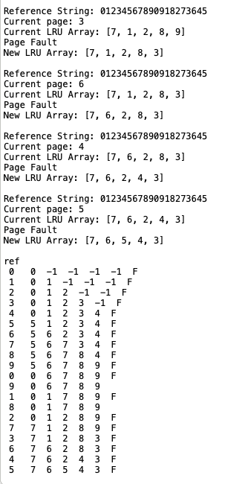

LFU simulation (beginning)

LFU simulation (in the middle)

LFU simulation (at the end)

